

July 23, 2020

{{Owner name}}

{{Address 1}}

{{city}}, {{state}} {{zip}}

[BARCODE……………………….]

**Subject: Your Property Has A Big Lot Size – That Means There is Increased Potential**

Hi {{owner name}},

We know your property has great potential for development due to its large lot size. By tapping into this “hidden value,” we are confident that your property is probably worth more than you think!

Our proprietary software, REulti ([www.reulti.com)](http://www.reulti.com)) produces a **REulti Report** that can tell a seller the maximum square footage that can be built on their property and then analyzes how that development potential can be leveraged for maximum ROI. I’m more than happy to send you a report at no obligation.

As a result, we value your property by a more sophisticated future development model and not by the traditional real estate agent’s method of simply comping your home against another sold property down the street.

I represent one of the biggest developers in Los Angeles who is currently looking for properties in your area right now. They are very serious buyers who have built many properties in your area already. I can provide a portfolio of addresses upon request.

If you have considered selling your property, now may be a good time. Our clients are professional developers who make clean offers, transact privately and without a lot of fuss. Interested in receiving a complimentary **Reulti Report** and learning about our system? Either way, I am more than happy to speak directly.

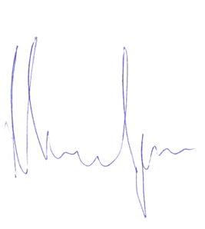For most homeowners, their property is their biggest asset. We understand the importance of getting the best value from a sales price. Through our approach in leveraging the home’s development value, I have consistently achieved 5-20% more than the traditional comparable approach.

Thank you for your time. Please contact me directly: (323) 303-4491or Maurice@californianestates.com.

Maurice Woolf

CEO, Californian Estates

DRE # 01959295

9255 W Sunset Blvd, #1000 | Los Angeles | CA | 90069

323.719.7779 | info@californianestates.com

www.californianestates.com